Not F**kin’ Sorry! by Not Your Circus Dog (The Dogs!)
A Learning Disabled & Neurodivergent led Performance Collective

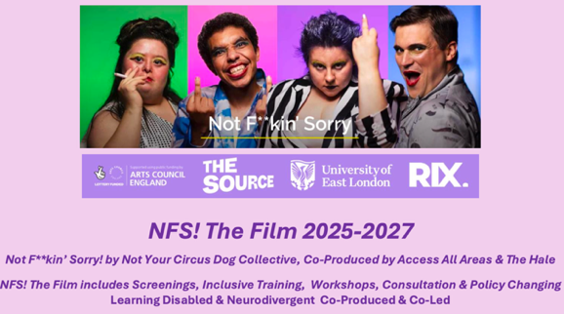

2-4pm The Source on Thursday 4 September 2025
Building an inclusive creative industry
Creative Industries Festival

Screened extracts from NFS! The Film for exploratory conversations with the creative industries together with public service and statutory organisations to foster an Ethic of Care, Inclusion and Implication for Equity. NFS! The Film is a powerful tool for self-advocacy, training for inclusion, and for influencing policy.

Not F**kin’ Sorry! by Not Your Circus Dog Collective, produced by Access All Areas and The Hale,
with the film funded by RIX Inclusive Research Institute and Newham Youth Empowerment Team

“In a time when disabled people are being pushed further into precarity, Not F**kin’ Sorry! isn’t just important—it’s vital. It amplifies voices that are so often silenced, forcing audiences to confront, to listen, and ultimately, to act. This wasn’t just a performance; it was a rallying cry.” 5-star review on NFS! in A Youngish Perspective 12.03.25

The Not Your Circus Dog Collective returned for a final UK national tour in Spring 2025 with Not F**kin’ Sorry! (NFS!) a 4- and 5-star, ACE funded, award-winning theatre production that had sold-out runs in 2019 and 2022. NFS! Is a wake-up call! Life affirming sexy punk crip queer cabaret-theatre whereby audiences are welcomed into a risk-taking and brave parody that implicates everyone who enters. It’s the story of survival, testimony, resilience, and celebration.

NFS! rejects the continual scapegoating and pity model of disability, to reframe & re-perform institutionalised popular culture including Children in Need, TV game shows, ableist stand-up comedians to expose systems of epistemic injustice that fuels society’s ableism: discrimination, trauma and shame!

Taking Michael Rothberg’s (2019) The Implicated Subject as a framework; we will also share some of our research to evidence the impact of NFS! We will offer these as examples of tools that can be embedded into policy, training and organisational systems.

The session will be co-facilitated by Liselle Terret (UEL/The Dogs) Nick Llewelyn (AAA), Adam Smith, Emma/Xandri Selwyn, Stephanie Newman, DJ Hassani (The Dogs), Heather Johnson, Katie Wheeler, Aifa Lennon (AAA/The Dogs).

“these four performers are some of the bravest, boldest, most candid and risk-taking on the contemporary London theatre scene.” – Disability Arts Online 2022

To reserve a place, book here:
For more information, please contact Liselle l.terret@uel.ac.uk

